CODE MẪU
org 0
led equ p2
KhoiTao:
mov led, #0

Main:
Call Tatdan0den7
sjmp Main

Sangdan0den7:
mov r0,#0
mov dptr,#Ma_sangdan0den7
call HienThi
ret
Tatdan0den7:
mov r0, #0
mov dptr,#Ma_tatdan0den7
call HienThi
ret
Tatdan7den0:
mov r0,#0
mov dptr,#Ma_tatdan7den0
call HienThi
ret
HienThi:
mov a,r0
movc a, @a+dptr
mov led,a
call Delay
inc r0
cjne r0, #9, HienThi
ret

Delay:
push 07h
push 06h
mov r6,#255
delay1:
mov r7,#255
djnz r7, $
djnz r6, delay1
pop 06h
pop 07h
ret

Ma_sangdan0den7: db 0feh, 0fch,0f8h, 0f0h,0e0h,0c0h,80h, 00h
Ma_tatdan0den7: db 0h, 01h, 03h, 07h, 0fh, 1fh, 3fh, 7fh, 0ffh
Ma_tatdan7den0: db 0h, 80h, 0c0h, 0e0h,0f0h, 0f8h, 0fch, 0feh, 0ffh
end
\\\\\\\\\\\\\\\\\\\\\\\\\\\\\\\\\\\\\\\\\\\\\\\\\\\\\\\\\\\\\\\\\\\\\\\\\\\\\\\\\\\\\\\\\\\\\\\\\\\\\\\\\
SÁNG DẦN 2 BÊN VÀO
Sangdan2benvao:
mov r0,#0
mov dptr,#Ma_sangdan2benvao
call HienThi1
ret
HienThi1:
mov a,r0
movc a, @a+dptr
mov led,a
call Delay
inc r0
cjne r0, #5, HienThi1
Ret
Ma_sangdan2benvao: db 0ffh, 7eh, 3ch, 18h, 00h

\\\\\\\\\\\\\\\\\\\\\\\\\\\\\\\\\\\\\\\\\\\\\\\\\\\\\\\\\\\\\\\\\\\\\\\\\\\\\\\\\\\\\\\\\\\\\\\\\\\\\\\\\
SÁNG ĐIỂM 2 BÊN VÀO
Sangdiem2benvao:
mov r0,#0
mov dptr,#Ma_sangdiem2benvao
call HienThi1
Ret
HienThi1:
mov a,r0
movc a, @a+dptr
mov led,a
call Delay
inc r0
cjne r0, #5, HienThi1
Ret
Ma_sangdiem2benvao: db 0ffh, 07eh, 0bdh, 0dbh, 0e7h
\\\\\\\\\\\\\\\\\\\\\\\\\\\\\\\\\\\\\\\\\\\\\\\\\\\\\\\\\\\\\\\\\\\\\\\\\\\\\\\\\\\\\\\\\\\\\\\\\\\\\\\\\
TẮT DẦN 2 BÊN VÀO
Tatdan2benvao:
Mov r0, #0
Mov dptr, #Ma_tatdan2benvao
Call HIenThi1
Ret
HienThi1:
Mov a, r0
Movc a, @a+dptr
Mov led, a
Call Delay
Inc r0
Cjne r0, #5, HienThi1
Ret
Ma_tatdan2benvao: db oh, 081h, 0c3h, 0e7h, offh
\\\\\\\\\\\\\\\\\\\\\\\\\\\\\\\\\\\\\\\\\\\\\\\\\\\\\\\\\\\\\\\\\\\\\\\\\\\\\\\\\\\\\\\\\\\\\\\\\\\\\\\\\
TẮT ĐIỂM 2 BÊN VÀO
Tatdiem2benvao:
Mov r0, #0
Mov dptr, #Ma_tatdiem2benvao
Call HienThi1
Ret
HienThi1:
Mov a, r0
Movc a, @a+dptr
Mov led, a
Call Delay
Inc r0
Cjne r0, #5, HienThi1
Ret
Ma_tatdiem2benvao: db 0h, 081h, 042h, 024h, 018h
\\\\\\\\\\\\\\\\\\\\\\\\\\\\\\\\\\\\\\\\\\\\\\\\\\\\\\\\\\\\\\\\\\\\\\\\\\\\\\\\\\\\\\\\\\\\\\\\\\\\\\\\\
XEN KẺ
CÁCH 1
Xenke:
mov r0, #0
mov dptr, #Ma_xenke
call HienThi2
ret
HienThi2:
mov a, r0
movc a, @a+dptr
mov led,a
call Delay
inc r0
cjne r0, #2,HienThi2
Ret
Ma_Xenke: db 0aah, 055h
CÁCH 2
Xenke:
Mov p0, #0aah
Mov p0, #55h

\\\\\\\\\\\\\\\\\\\\\\\\\\\\\\\\\\\\\\\\\\\\\\\\\\\\\\\\\\\\\\\\\\\\\\\\\\\\\\\\\\\\\\\\\\\\\\\\\\\\\\\\\
SÁNG DẦN 0 ĐẾN 7
Sangdan0den7:
mov r0,#0
mov dptr, #Ma_sangdan0den7
call HienThi
Ret
HienThi:
mov a,r0
movc a, @a+dptr
mov led,a
call Delay
inc r0
cjne r0, #9, HienThi
Ret
Ma_Sangdan0den7: db offh, 0feh, 0fch, 0f8h, 0f0h, 0e0h, 0c0h, 80h, 0h

\\\\\\\\\\\\\\\\\\\\\\\\\\\\\\\\\\\\\\\\\\\\\\\\\\\\\\\\\\\\\\\\\\\\\\\\\\\\\\\\\\\\\\\\\\\\\\\\\\\\\\\\\
SÁNG DẦN 7 ĐẾN 0

Sangdan7den0:
mov r0,#0
mov dptr, #Ma_sangdan7den0
call HienThi
Ret
HienThi:
mov a,r0
movc a, @a+dptr
mov led,a
call Delay
inc r0
cjne r0, #9, HienThi
Ret

Ma_sangdan7den0: db 0ffh, 07fh, 03fh, 01fh, 00fh, 007h, 003h, 001h, 0h

\\\\\\\\\\\\\\\\\\\\\\\\\\\\\\\\\\\\\\\\\\\\\\\\\\\\\\\\\\\\\\\\\\\\\\\\\\\\\\\\\\\\\\\\\\\\\\\\\\\\\\\\\
TẮT DẦN 0 ĐẾN 7
Tatdan0den7:
Mov r0, #0
Mov dptr, Ma_tatdan0den7
Call HienThi
Ret
HienThi:
Mov a, r0
Movc a, @a+dptr
Mov led, a
Call Delay
Inc r0
Cjne r0, #9, HienThi
Ret
Ma_tatdan0den7: 0h, 001h, 003h, 007h, 00fh, 01fh, 03fh, 07fh, 0ffh

\\\\\\\\\\\\\\\\\\\\\\\\\\\\\\\\\\\\\\\\\\\\\\\\\\\\\\\\\\\\\\\\\\\\\\\\\\\\\\\\\\\\\\\\\\\\\\\\\\\\\\\\\
TẮT DẦN 7 ĐẾN 0
Tatdan7den0:
Mov r0, #0
Mov dptr, Ma_tatdan7den0
Call HienThi
Ret
HienThi:
Mov a, r0
Movc a, @a+dptr
Mov led, a
Call Delay
Inc r0
Cjne r0, #9, HienThi
Ret
Ma_tatdan7den0: db 0h, 080h, 0c0h, 0e0h, 0f0h, 0f8h, 0fch, 0feh, 0ffh
\\\\\\\\\\\\\\\\\\\\\\\\\\\\\\\\\\\\\\\\\\\\\\\\\\\\\\\\\\\\\\\\\\\\\\\\\\\\\\\\\\\\\\\\\\\\\\\\\\\\\\\\\
SÁNG ĐIỂM 0 ĐẾN 7
Sangdiem0den7:
Mov r0, #0
Mov dptr, #Ma_sangdiem0den7
Call HienThi
Ret
HienThi:
Mov a, r0
Movc a, @a+dptr
Mov led, a
Call delay
Inc r0
Cjne r0, #8, HienThi
Ret
Ma_sangdiem0den7: db 0feh, 0fdh, 0fbh, 0f7h, 0efh, 0dfh, 0bfh, 07fh
\\\\\\\\\\\\\\\\\\\\\\\\\\\\\\\\\\\\\\\\\\\\\\\\\\\\\\\\\\\\\\\\\\\\\\\\\\\\\\\\\\\\\\\\\\\\\\\\\\\\\\\\\
SÁNG ĐIỂM 7 ĐẾN 0
Sangdiem7den0:
Mov r0, #0
Mov dptr, #Ma_sangdiem7den0
Call HienThi
Ret
HienThi:
Mov a, r0
Movc a, @a+dptr
Mov led, a
Call delay
Inc r0
Cjne r0, #8, HienThi
Ret
Ma_sangdiem7den0: db 07fh, 0bfh, 0dfh, 0efh, 0f7h, 0fbh, 0fdh, 0feh
\\\\\\\\\\\\\\\\\\\\\\\\\\\\\\\\\\\\\\\\\\\\\\\\\\\\\\\\\\\\\\\\\\\\\\\\\\\\\\\\\\\\\\\\\\\\\\\\\\\\\\\\\
TẮT ĐIỂM 0 ĐẾN 7
Tatdiem0den7:
Mov r0, #0
Mov dptr, #Ma_tatdiem0den7
Call HienThi
Ret
HienThi:
Mov a, r0
Movc a, @a+dptr
Mov led, a
Call delay
Inc r0
Cjne r0, #8, HienThi
Ret
Ma_tatdiem0den7: db 01h, 02h, 04h, 08h, 10h, 20h, 40h, 80h
\\\\\\\\\\\\\\\\\\\\\\\\\\\\\\\\\\\\\\\\\\\\\\\\\\\\\\\\\\\\\\\\\\\\\\\\\\\\\\\\\\\\\\\\\\\\\\\\\\\\\\\\\
TẮT ĐIỂM 7 ĐẾN 0
Tatdiem7den0:
Mov r0, #0
Mov dptr, #Ma_tatdiem7den0
Call HienThi
Ret
HienThi:
Mov a, r0
Movc a, @a+dptr
Mov led, a
Call delay
Inc r0
Cjne r0, #8, HienThi
Ret
Ma_tatdiem7den0: db 80h, 40h, 20h, 10h, 08h, 04h, 02h, 01h
\\\\\\\\\\\\\\\\\\\\\\\\\\\\\\\\\\\\\\\\\\\\\\\\\\\\\\\\\\\\\\\\\\\\\\\\\\\\\\\\\\\\\\\\\\\\\\\\\\\\\\\\\
SÁNG DỒN 7 ĐẾN 0
Sangdon7den0:
mov r0,#0
mov dptr,#Ma_sangdon7den0
call HienThi1
Ret
HienThi1:
mov a,r0
movc a, @a+dptr
mov led,a
call Delay
inc r0
cjne r0, #36, HienThi1
Ret
Ma_Sangdon7den0: db 07fh, 0bfh, 0dfh, 0efh, 0f7h, 0fbh, 0fdh, 0feh
db 07eh, 0beh, 0deh, 0eeh, 0f6h, 0fah, 0fch
db 07ch, 0bch, 0dch, 0ech, 0f4h, 0f8h
db 078h, 0b8h, 0d8h, 0e8h, 0f0h
db 070h, 0b0h, 0d0h, 0e0h
db 060h, 0a0h, 0c0h
db 040h, 80h
db 0h
\\\\\\\\\\\\\\\\\\\\\\\\\\\\\\\\\\\\\\\\\\\\\\\\\\\\\\\\\\\\\\\\\\\\\\\\\\\\\\\\\\\\\\\\\\\\\\\\\\\\\\\\\
SÁNG DỒN 0 ĐẾN 7

Sangdon0den7:
mov r0, #0
mov dptr, #Ma_sangdon0den7
call HienThi1
ret
HienThi1:
mov a,r0
movc a, @a+dptr
mov led,a
call Delay
inc r0
cjne r0, #36, HienThi1
Ret
Ma_Sangdon0den7: db 0feh, 0fdh, 0fbh, 0f7h, 0efh, 0dfh, 0bfh, 07fh
db 07eh, 07dh, 07bh, 077h, 06fh, 05fh, 03fh
db 03eh, 03dh, 03bh, 037h, 02fh, 01fh
db 01eh, 01dh, 01bh, 017h, 00fh
db 00eh, 00dh, 00bh, 007h
db 006h, 005h, 003h
db 002h, 001h
db 0h
\\\\\\\\\\\\\\\\\\\\\\\\\\\\\\\\\\\\\\\\\\\\\\\\\\\\\\\\\\\\\\\\\\\\\\\\\\\\\\\\\\\\\\\\\\\\\\\\\\\\\\\\\
TẮT DỒN 7 ĐẾN 0
Tatdon7den0:
mov r0, #0
mov dptr, #Ma_tatdon7den0
call HienThi1
Ret
HienThi1:
mov a,r0
movc a, @a+dptr
mov led,a
call Delay
inc r0
cjne r0, #36, HienThi1
Ret
Ma_tatdon7den0 : db 001h, 002h, 004h, 008h, 010h, 020h, 040h, 080h
db 081h, 082h, 084h, 088h, 090h, 0a0h, 0c0h
db 0c1h, 0c2h, 0c4h, 0c8h, 0d0h, 0e0h
db 0e1h, 0e2h, 0e4h, 0e8h, 0f0h
db 0f1h, 0f2h, 0f4h, 0f8h
db 0f9h, 0fah, 0fch
db 0fdh, 0feh
db 0ffh
\\\\\\\\\\\\\\\\\\\\\\\\\\\\\\\\\\\\\\\\\\\\\\\\\\\\\\\\\\\\\\\\\\\\\\\\\\\\\\\\\\\\\\\\\\\\\\\\\\\\\\\\\
TẮT DỒN 0 ĐẾN 7
Tatdon0den7:
mov r0,#0
mov dptr, #Ma_tatdon0den7
call HienThi
Ret
HienThi1:
mov a,r0
movc a, @a+dptr
mov led,a
call Delay
inc r0
cjne r0, #36, HienThi1
Ret
Ma_tatdon0den7: db 080h, 040h, 020h, 010h, 008h, 004h, 002h, 001h
db 081h, 041h, 021h, 011h, 009h, 005h, 003h
db 083h, 043h, 023h, 013h, 00bh, 007h
db 087h, 047h, 027h, 017h, 00fh
db 08fh, 04fh, 02fh, 01fh
db 09fh, 05fh, 03fh
db 0bfh, 07fh
db 0ffh

\\\\\\\\\\\\\\\\\\\\\\\\\\\\\\\\\\\\\\\\\\\\\\\\\\\\\\\\\\\\\\\\\\\\\\\\\\\\\\\\\\\\\\\\\\\\\\\\\\\\\\\\\
LED 7 ĐOẠN
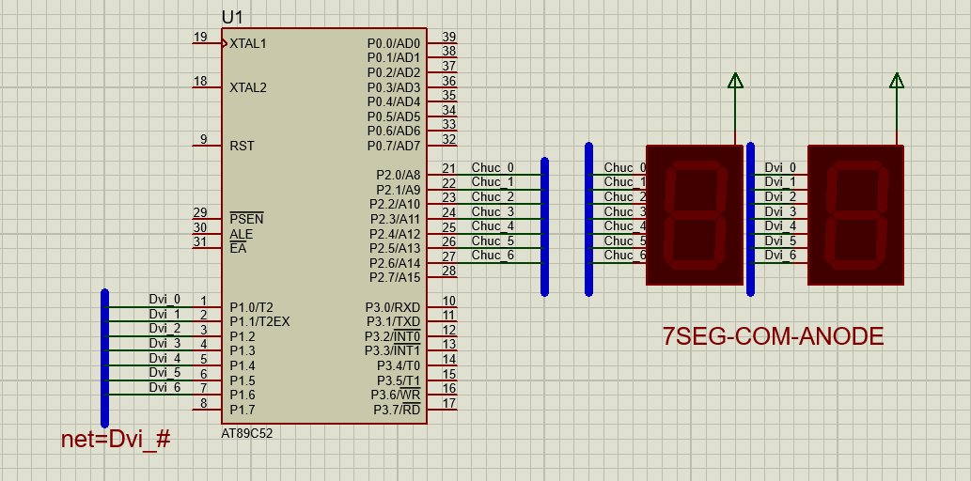

org 0
chuc equ p2
donvi equ p1
so_led equ 30h
KhoiTao:
mov chuc, #0ffh
mov donvi,#0ffh
mov so_led,#0
mov dptr, #ma_led
main:
call Dem00den99
call Dem99ve00
call Dem70ve20
sjmp main
Dem00den99:
mov so_led, #0
demlen:
call HienThi
call Delay
inc so_led
mov a, so_led
cjne a, #100, demlen
ret
Dem99ve00:
mov so_led, #99
demxuong:
call HienThi
call Delay
dec so_led ;THAY DOI DEM LEN HOAC DEM XUONG
mov a, so_led
cjne a, #-1, demxuong ;THAY DOI GIA TRI DEM DEN CUOI DE SO SANH
ret
Dem70ve20:
mov so_led, #70 ;GAN GIA TRI BAT DAU DEM
demxuong1:
call HienThi
call Delay
dec so_led
mov a, so_led
cjne a, #19, demxuong1
ret
HienThi:
mov a, so_led
mov b, #10
div ab
movc a, @a+dptr
mov chuc, a
mov a, b
movc a, @a+dptr
mov donvi, a
ret
Delay:
push 07h
push 06h
push 05h
mov r5, #3 ;THAY DOI THOI GIAN DEM
delay1:
mov r6,#200
delay2:
mov r7, #200
djnz r7, $
djnz r6, delay2
djnz r5, delay1
pop 05h
pop 06h
pop 07h
ret
ma_led: db 0c0h, 0f9h, 0a4h, 0b0h, 99h ;GIU NGUYEN CO DINH
db 92h, 82h, 0f8h, 80h, 90h
End

\\\\\\\\\\\\\\\\\\\\\\\\\\\\\\\\\\\\\\\\\\\\\\\\\\\\\\\\\\\\\\\\\\\\\\\\\\\\\\\\\\\\\\\\\\\\\\\\\\\\\\\\\
LED 7 ĐOẠN CÓ NÚT NHẤN
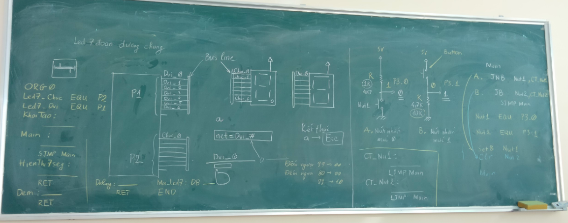
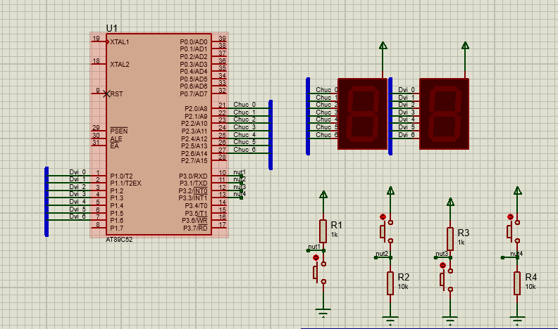

org 0
led7_chuc equ p2
led7_donvi equ p1
so_led equ 30h
nut1 equ p3.0
nut2 equ p3.1
nut3 equ P3.2
nut4 equ p3.3
KhoiTao:
mov led7_chuc, #0ffh ;tat het
mov led7_donvi, #0ffh ;tat het
mov so_led, #0 ;gan gia tri 0 cho so_led
mov dptr, #Ma_led7_a

setb nut1
clr nut2
setb nut3
clr nut4
main:
jnb nut1, ct_nut1 ;khi nhan thi no nhay den chuong trinh nut1
jb nut2, ct_nut2
jnb nut3, ct_nut3
jb nut4, ct_nut4
sjmp main
ct_nut1:
mov so_led, #0 ;gan gia tri bat dau dem
call Dem00den99
ljmp main
ct_nut2:
mov so_led, #99
call Dem99ve00
ljmp main
ct_nut3:
mov so_led, #50
call Dem50den99
ljmp main
ct_nut4:
mov so_led, #88
call Dem88ve80
ljmp main
Dem00den99:
Dem50den99:
Demlen:
call HienThi
call Delay
inc so_led ;thay doi dem len hoac dem xuong
mov a, so_led
cjne a, #100, Demlen ;thay doi gia tri ket thuc
ret
Dem99ve00:
Demxuong:
call HienThi
call Delay
dec so_led
mov a, so_led
cjne a, #-1, Demxuong
ret
Dem88ve80:
Demxuong1:
call HienThi
call Delay
dec so_led ;thay doi dem len hoac dem xuong
mov a, so_led
cjne a, #79, Demxuong1 ;thay doi gia tri ket thuc
ret
HienThi:
mov a, so_led
mov b, #10
div ab
movc a, @a+dptr
mov led7_chuc, a
mov a,b
movc a, @a+dptr
mov led7_donvi, a
ret
Delay:
push 07h
push 06h
push 05h
mov r5, #2 ;thay doi thoi gian dem
delay1:
mov r6, #200
delay2:
mov r7, #200
djnz r7,$
djnz r6, delay2
djnz r5, delay1
pop 05h
pop 06h
pop 07h
ret
Ma_led7_a:
db 0c0h, 0f9h, 0a4h, 0b0h, 99h
db 92h, 82h, 0f8h, 80h, 90h

end

\\\\\\\\\\\\\\\\\\\\\\\\\\\\\\\\\\\\\\\\\\\\\\\\\\\\\\\\\\\\\\\\\\\\\\\\\\\\\\\\\\\\\\\\\\\\\\\\\\\\\\\\\\\
LED MA TRẬN CHẠY CHỮ

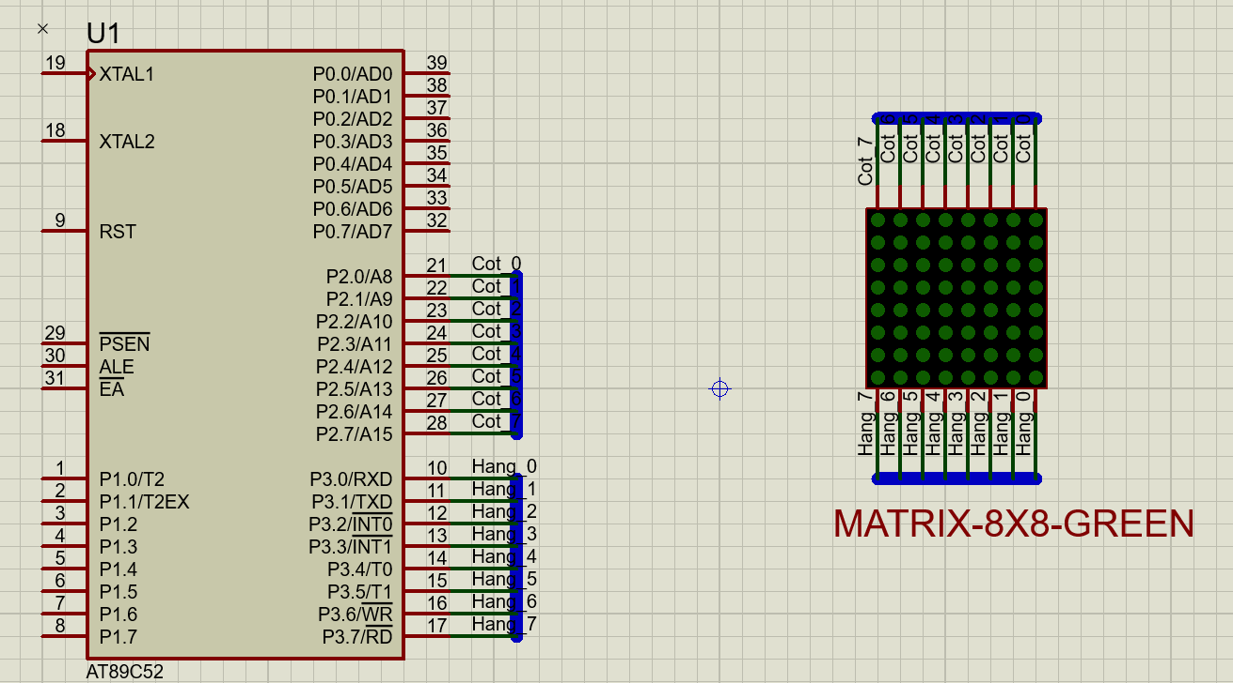

+ Mỗi cột khi được quét sẽ có 1 dữ liệu của 8 hàng. Như vậy 8 lần quét thì ta sẽ có 8 dữ liệu
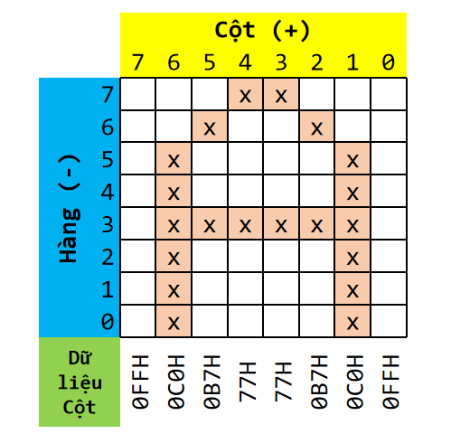
+ Ví dụ: 1 chữ cái “A” khi hiển thị trên ma trận sẽ có dữ liệu từng cột như s
8x8 [Cột dương và Hàng âm]

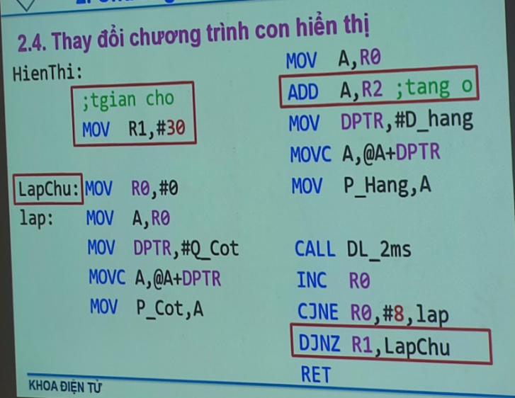

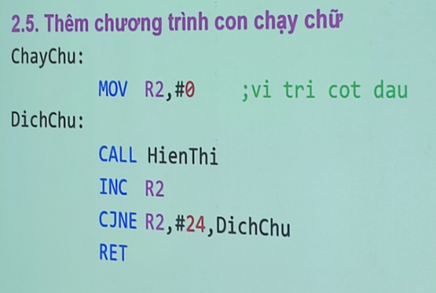

org 0
P_Cot EQU P2
P_Hang EQU P3
KhoiTao:
MOV P_Cot, #0H ;tat het, COT la duong chung nen phai phan cuc nguoc la 0H
MOV P_Hang,#0FFH ;tat het, HANG la am chung nen ohai phan cuc nguoc la 0FFH
Main:
call chaychutraiquaphai
SJMP Main

HienThi:
MOV R1,#10 ;Cot 0
lapchu:
mov r0, #0
lap:
MOV A,R0
MOV DPTR,#Q_Cot
MOVC A,@A+DPTR
MOV P_Cot,A

MOV A,R0
add a, r2;tang o
MOV DPTR,#machu
MOVC A,@A+DPTR
MOV P_Hang, A

CALL DL_2ms
INC R0
CJNE R0,#8,lap
djnz r1, lapchu
RET
;;;;;;CHAY CHU TRAI QUA PHAI
chaychutraiquaphai:
mov r2, #0
dichchu:
call HienThi
inc r2
cjne r2, #48, dichchu ;-------> ;;;;;;NÊN TRỪ RA 8 BIT
;cjne --> so sanh nhay neu khong bang
ret
;;;;;;CHAY CHU PHAI QUA TRAI
chaychuphaiquatrai:
mov r2, #48
dichchu1:
call HienThi
dec r2
cjne r2, #0, dichchu1
ret
DL_2ms: Push 07h
Push 06h
MOV R5,#20
D_2ms_1:MOV R6,#100
DJNZ R6,$
DJNZ R5, D_2ms_1
Pop 06h
Pop 07h
RET

;Quet theo cot :
;quet cot tu phai qua trai
;Q_Cot: DB 01H, 02H, 04H, 08H, 10H, 20H, 40H, 80H
Q_Cot: DB 80H, 40H, 20H, 10H, 08H, 04H, 02H, 01H ;quet cot tu trai qua phai
machu: ;data cot
db 0ffh, 0ffh, 0ffh, 0ffh, 0ffh, 0ffh, 0ffh, 0ffh ;trang trang

db 0FFH, 9EH, 7CH, 7AH, 76H, 6EH, 9EH, 0FFH
db 81H, 7EH, 7EH, 7EH, 81H, 0FFH, 0FEH, 0FFH
db 0DEH, 0BEH, 0H, 0FEH, 0FEH, 0FFH, 81H, 7EH
db 7EH, 7EH, 0BDH, 0F7H, 0H, 76H, 7EH, 7EH
db 81H, 0FFH, 7FH, 7FH, 0H, 7FH, 7FH, 0FFH
db 0ffh, 0ffh, 0ffh, 0ffh, 0ffh, 0ffh, 0ffh, 0ffh ;trang trang
END
